Instructions for Students:
- Complete this report during the 30-minute in-class test.
- Take screenshots for all outputs as evidence.
- Fill in all commands, IP addresses, and observations in the respective sections.
- Submit the completed report along with screenshots in Moodle immediately after the test

COIT20261 – Week 3 Lab Report Template
Max Duration: 30 minutes | Max Marks: 10
Student Name: dishant mahendrakumar patel
Student ID: 12313596
Tutorial Group: MEL1
Date of Lab: 25/03/2026

Task 1
1. Network Topology
Network Diagram / Screenshot:
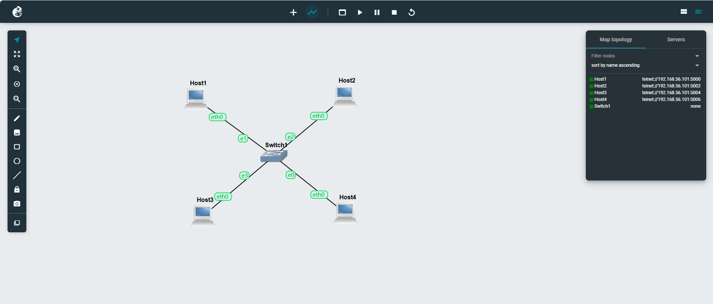
2. IP Configuration Steps
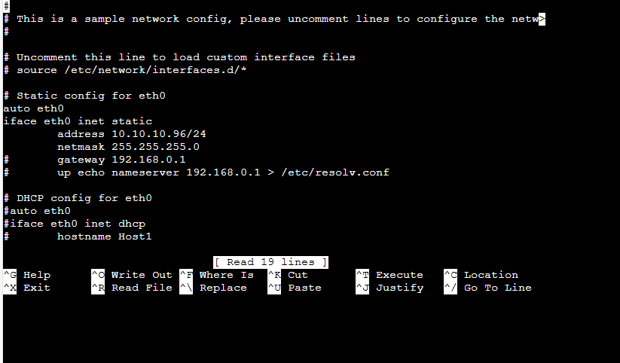

3. Static IP (ip command):
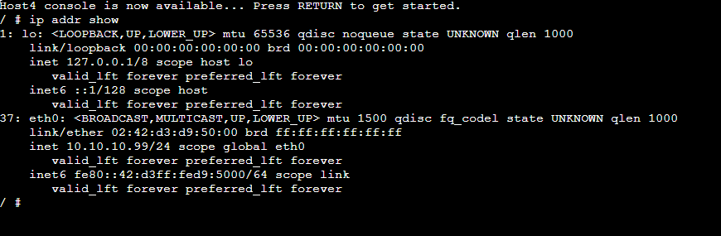
Task 2
3. Connectivity Testing (Ping)
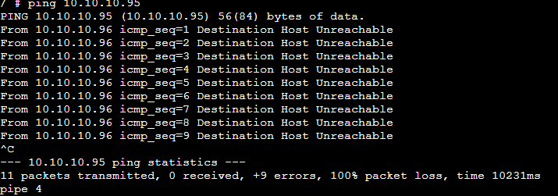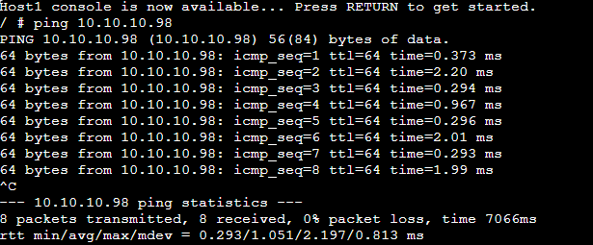
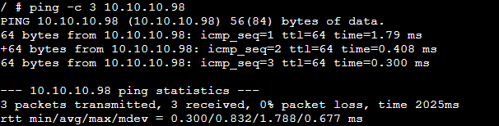

Task 3
4. Observations / Issues
- Issues encountered during configuration:
* IP Address Conflicts: You accidentally assigned the same IP to two different hosts.
* Subnet Mask Mismatch: Using 255.255.255.0 on one host and 255.0.0.0 on another, preventing them from "seeing" each other.
* Default Gateway Errors: Entering the wrong gateway IP, which would stop your hosts from communicating outside their local network.
* Typographical Errors: Simple typos in the numerical octets (e.g., typing 192.186... instead of 192.168...).

- Solutions applied:
* Verification: Used commands like ipconfig (Windows) or ifconfig / ip addr (Linux) to double-check the current settings.
* Correction: Re-entered the static IP information carefully through the GUI or command line.
* Testing: Used the ping command repeatedly after each change to verify when the connection was finally established.
5. Reflection / Learning
* Connectivity Basics: Understanding how the ping command works to test end-to-end connectivity.
* Addressing Logic: How IP addresses and subnet masks must be logically aligned for devices to communicate.
* Troubleshooting Skills: Learning to interpret error messages like "Destination Host Unreachable" or "Request Timed Out" to diagnose network faults.

